Ring width data was translated into annual diameter increments using the diameter at breast height measured in the field and a bark coefficient (Table 3) to estimate the decrease in bark thickness on successively smaller diameter trees:

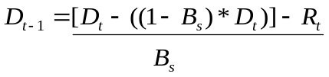

Where B_{s} is the bark coefficient for species s, D_{t} is the diameter at breast height at year t, D_{t-1} is the diameter at breast height at year t-1 and R_{t} is two times the ring width during year t.

Table 3. Bark thickness coefficients and references used to estimate dbh given annual ring width increments.
Species | Bark Coeff. | Reference
ABGR | 0.914 | Finch 1948
ABLAS | 0.970 | Finch 1948
ACMA | 0.961 | Smith and Kozak 1973
CHNO | 0.970 | Smith and Kozak 1976
PIEN | 0.956 | Smith and Kozak 1974
PICO | 0.961 | Smith and Kozak 1972
PIMO | 0.951 | Smith and Kozak 1975
PIPO | 0.897 | Smith and Kozak 1977
POBA | 0.942 | Smith and Kozak 1968
POTR | 0.935 | Smith and Kozak 1967
PSME | 0.830 | Smith and Kozak 1970
THPL | 0.959 | Smith and Kozak 1969
TSHE | 0.914 | Smith and Kozak 1971

